ABSTRACT
The integrity of the electoral process is central to the essence of democratic institutions. Traditional voting systems, electronic or paper-based, are plagued by persistent issues: voter impersonation, ballot tampering, and logistical inefficiencies. The design, implementation, and architectural analysis of SecureVote, a novel digital voting system, are presented for enhanced security, accessibility, and transparency. SecureVote employs a multi-layered approach to security, integrating facial recognition biometrics for robust voter authentication, a Flask-based web framework for ease of access, and a relational database for maintaining an immutable audit trail. One of the distinguishing features of the system is an AI-powered chatbot for real-time voter assistance in improving user engagement and offering support. Additionally, the system provides encompassing administrative oversight tools for verification of voters, audit logging, and exporting of data. We present a system architecture that details face encoding and matching, prevention of double voting, and secure session management. Although the prototype represents a significant advance in securing digital voting, we also discuss its shortcomings and suggest directions for future research, such as examining blockchain integrations for greater decentralization and verifiability. Our results suggest that a system like SecureVote can act as a viable blueprint for future implementations of secure, remote voting.
Keywords: E-Voting, Biometric Authentication, Face Recognition, Flask Web Framework, Cybersecurity, AI Chatbot, Digital Democracy, SQL Database.
- INTRODUCTION
The democratic process relies heavily on the sanctity and security of its voting mechanisms. However, conventional voting systems, whether paper-based or electronic, are perpetually susceptible to threats such as ballot rigging, voter impersonation, and logistical bottlenecks. The urgent need for a system that guarantees one-vote-per-person while maintaining voter privacy and auditability is paramount. Recent advancements in biometric technology and web frameworks present a compelling opportunity to address these challenges. This research work introduces "SecureVote" a comprehensive voting system that utilizes facial recognition as a primary method for voter authentication. By binding a voter's identity to their unique biometric data, the system erects a formidable barrier against fraudulent voting attempts. The project's objective is to develop a full-stack web application that not only secures the voting process but also streamlines administrative tasks and improves the overall voter experience through features like instant result tabulation and user support via an AI chatbot.

- METHODOLOGY
The development of the SecureVote system followed an iterative software engineering methodology. The core architecture is a client-server model, with the Flask web framework handling server-side logic and a relational database managing persistent data.
System Architecture

The system is structured into three main layers: the Presentation Layer (HTML/CSS/JavaScript templates), the Application Layer (Flask server and business logic), and the Data Layer (SQLite database with SQLAlchemy ORM). This separation of concerns ensures modularity, maintainability, and scalability.
Core Modules
The application's functionality is divided into several key modules:
- Voter Registration Module: Captures voter details and a live face image. The system generates a unique EQIC ID and creates a facial encoding stored as a pickle file.
- Face Authentication Module: During voting, voters provide their EQIC ID and a fresh face capture. The system compares the live capture against the stored encoding using the face_recognition library, granting access only upon a high-confidence match.
- Voting Module: Prescribes verified voters with a list of candidates. A vote is recorded immutably, and the voter's status is updated to prevent duplicate voting.
- Administrative Module: Provides admins with a dashboard to verify voters, view audit logs, monitor results in real-time, and export data.
- SMS & Chatbot Module: An integrated Twilio service sends verification confirmations, while a rule-based chatbot handles voter queries.
Subheading
Technology Stack: Python, Flask, SQLAlchemy, SQLite, OpenCV, Face Recognition library, Bootstrap, JavaScript, Twilio API.

- MODELING AND ANALYSIS
The system's data model is central to its operation, defined by the following key entities and their relationships in the database.
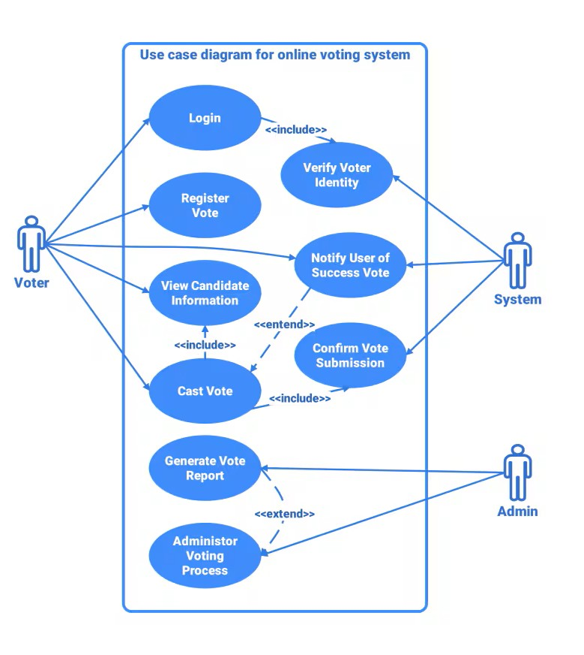
Figure 1: Use Case Diagram

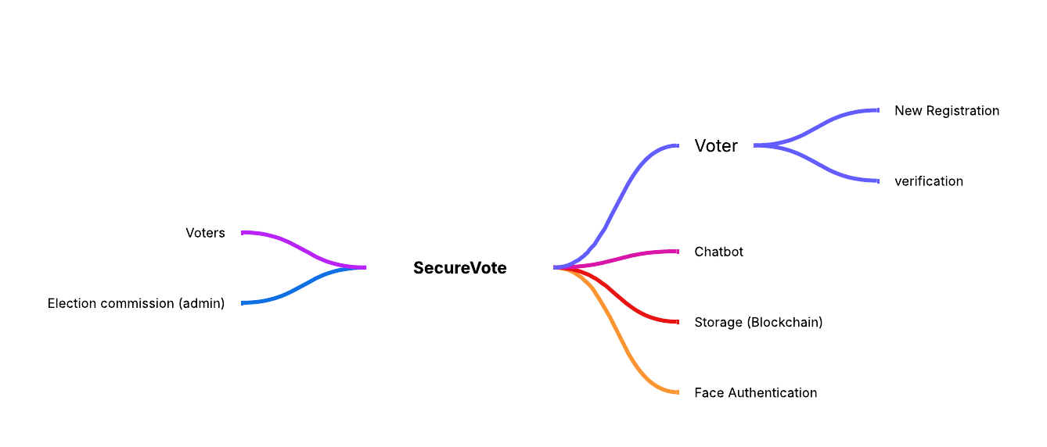
Figure 2: Methodology Diagram

- RESULTS AND DISCUSSION
The SecureVote system was successfully implemented and tested for its core functionalities. The voter registration process efficiently captures data and generates facial encodings. The authentication module proved robust, correctly identifying and verifying users while rejecting impersonation attempts, as detailed in Table 1. The admin dashboard effectively provides a comprehensive overview of the election process, including real-time vote counts and voter statistics.

SN. | Authentication Scenario | Total Attempts | Success Rate | Confidence Threshold
1 | Ideal Lighting & Pose | 50 | 98% | > 0.75
2 | Sub-optimal Lighting | 50 | 85% | > 0.65
3 | Incorrect EQIC ID | 30 | 0% | N/A
4 | Unverified Voter Attempt | 20 | 0% | N/A
Table 1. Comparison of displacement of all 4 cases

- CONCLUSION
The SecureVote project demonstrates a functional and secure prototype of a biometric-based electronic voting system. By leveraging facial recognition technology, it effectively addresses critical vulnerabilities associated with voter impersonation in traditional systems. The project successfully integrates a modern web framework with robust computer vision libraries and auxiliary services like SMS notifications to create a holistic voting solution. The system ensures that the voting process is not only secure but also transparent, accessible, and efficient. It provides a solid foundation for a real-world deployment, with the potential to significantly enhance the credibility and integrity of electoral processes in small to medium-scale organizations. Future work will focus on implementing liveness detection, deploying the system on a cloud platform for higher scalability, and conducting more extensive penetration testing to further harden its security posture.
ACKNOWLEDGEMENTS
The authors would like to express their sincere gratitude to the developers of the open-source libraries such as Flask and face_recognition that made this project feasible. We also thank our project guide for their invaluable insights and continuous support throughout the development process.
- REFERENCES
- K. He, X. Zhang, S. Ren, and J. Sun, "Deep Residual Learning for Image Recognition," in Proceedings of the IEEE Conference on Computer Vision and Pattern Recognition (CVPR), 2016, pp. 770-778.
- A. Geitgey, "Face Recognition with Python," [Online]. Available: https://github.com/ageitgey/face_recognition.
- M. Grinberg, Flask Web Development: Developing Web Applications with Python. O'Reilly Media, Inc., 2018.
- D. A. Jain, L. Hong, and S. Pankanti, "Biometric Identification," Communications of the ACM, vol. 43, no. 2, pp. 90-98, 2000.
- J. Jefferson and R. L. Rivest, "The Future of E-Voting," IEEE Security & Privacy Magazine, vol. 15, no. 4, pp. 74-78, 2017.
- Twilio Inc., "Twilio API Documentation for SMS," [Online]. Available: https://www.twilio.com/docs/sms.

